SERIALIZATION PROCESS
Michael Mays
UMUC
June 24 2018

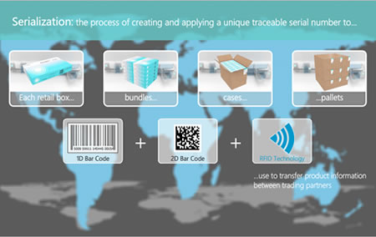

Serialization process refers to the practice of transfiguring an object from its natural into a stream of bytes to transmit or store the object in a database, a memory or even in a file (McLennan et al., 2017). In other words, serialization is the approach of changing natural state of an object to a textual form to persevere it in the storage medium as well as exchanging it over the network. The most important aspect of serialization is that it necessitates the exchange of data across the internet and saving it in a cross-platform-compatible format. It also allows for saving of the transformed data in a storage medium for later use (McLennan et al., 2017).
Object serialization is divided into three types, that is, binary serialization, SOAP serialization and XML serialization. SOAP serialization is formulated to exchange processes by the use of XML by use of Xmlserializer (McLennan et al., 2017). The XML Serialization refers to serializing a Net Object to the form of XML. Binary Serialization refers to the approach of altering Net Objects into a byte stream.
Technically the serialization process helps in manipulation and interpretation of objects in different ways. As such, it uses XML to concern objects and support storage of the object over a network or even store it in a file. Through XML, serialization helps to retrieve and convert objects back to the original state. Serialization also uses Java Object Notations (JSON) for conversion of objects (McLennan et al., 2017).
The serialization process looks like serialized codes. For example, the Test Serial objects serialized into the file temp which displays hexadecimal form of test serial as shown.
AC ED 00 05 73 72 00 OA 53 64 72 69 61 6D 54 65
73 74 00 0C 34 A0 FE B1 DD F9 02 00 02 42 00 05
63 6F 75 6E 74 42 a0 07 76 65 72 73 69 6B 6E 78
70 A0 64

The hexadecimal form is comprised of two byte members; the public byte Version = 100; and the public byte count = 0;
Below is a sample of a serialized object of student class.

import java.io.*;
class Persist{
unrestricted static void main(String args[])throws Exception{
Student s1 =new Student(211,"ravi");

FileOutputStream fout=new FileOutputStream("f.txt");
ObjectOutputStream out=new ObjectOutputStream(fout);
out.writeObject(s1);
out.flush();
System.out.println("success");
}
}
The general serialization process works in accordance with the following model:

Object

Bytes

Database memory file.

In this process, the object is serialized to a stream comprised of data concerning objects type like culture, version, and also the assembly name and hence the information processes can be preserved in file, memory or a database (Dauda et al., 2017).
• It outlays the metadata of the class linked with an object.
• It writes out the description of the super class until it finds java.lang.object.
• After writing the metadata information, it then starts with the top most super class actual data related to the object.
• Recursively, it writes the data related to the object ranging from the least super class to the topmost super class.
There are many exciting facts concerning object serialization which the reader should be interested in. As such, serialization process necessitates for refactoring by allowing for adding unique fields to a class, altering the fields from static to nonstatic and also altering the fields from transient to nontransient. Moreover, serialized information can be signed and sealed by use of javax.crypto.sealedObject and/or java.security.SignedObject wrapper. Interestingly, this process generates a gift box alongside the real object which allows one to seal and sign the serialized information thus encryption (Atzeni, &Atzori, 2017). Object serialization can be placed a proxy in one's stream since, at times, complete serialization is unnecessary. One could mark the fields of transient. However, the outlaid class would descriptively generate a code to examine whether the field incepted during every accession.
In conclusion, object serialization is more accurate in providing enough chances to hack out of sticky situations. Moreover, serialization helps in making room for saving the state of an object as well as restructuring it to meet the required standards for storage and sharing information.
References
Atzeni, M., & Atzori, M. (2017, October). CodeOntology: RDF-ization of source code. In International Semantic Web Conference (pp. 20-28). Springer, Cham.
Dauda, A. B., Saber, Z., Alotaibi, F., Mustapha, M. A., & Abdullah, M. T. (2017, October). Effect of serialized messaging on Web services performance. In Computing Networking and Informatics (ICCNI), 2017 International Conference on (pp. 1-5). IEEE.
McLennan, C. S., Kramer, J. T., Taylor, J. P., & Venerable, M. (2017). U.S. Patent No. 9,659,020. Washington, DC: U.S. Patent and Trademark Office.

